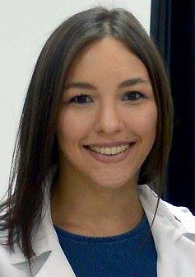Tiffany Ríos-Fuller, PhD, is a postdoctoral fellow in the lab of Robert Schneider, PhD, at NYU Langone Health, where she is working to advance our understanding of the molecular mechanisms that drive breast cancer development and progression. She was awarded a PhD in Cellular and Molecular Biology from Universidad Central del Caribe-School of Medicine. ACS GRANT While poorly studied, the changes in the protein synthesis mechanism result in the selective expression of certain proteins that reprogram cells to become cancerous, develop into tumors and metastasize. We identified a factor known as death associated protein 5 (DAP5), which we show is absolutely essential for breast cancer metastasis in a clinically relevant mouse model. We will investigate the function of DAP5 using cell culture and animal models of metastatic human breast cancer to determine how DAP5 promotes selective protein production of specific genes involved in breast cancer cell survival and metastasis. We will address a major gap in knowledge on understanding the basis of breast cancer metastasis, by targeting the activity of a poorly studied regulatory pathway that has been largely unknown in cancer biology. Ultimately, the proposed research plan will advance our knowledge of metastatic breast and other cancers and contribute to development of new therapeutic strategies.

Survivor Bio –Laura Renegar, Breast cancer survivor
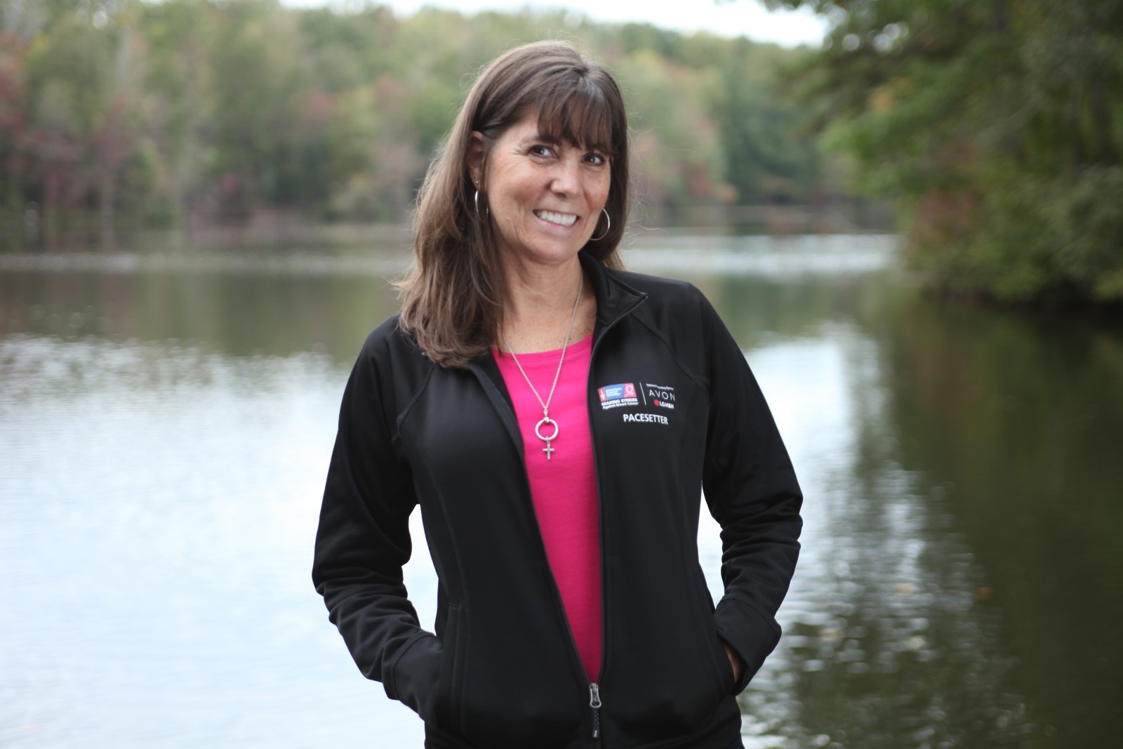Laura Renegar is the team leader of the Primax Pink Warriors, a Making Strides Against Breast Cancer team for the American Cancer Society. She has a team of people passionate about helping women as they face a breast cancer diagnosis and celebrating them as they reach survivorship milestones. She is thankful that 2023 will be their sixteenth year partnering with Making Strides. Running this team has changed her life and her perspective on breast cancer. They have broken every single goal she could have ever imagined. Many years ago, her mom passed away from breast cancer and she knew her family had a higher risk, but she really did not know what that meant, until she herself was diagnosed. She has always heard about finding the silver linings and blessings in every trial, but until she started digging into her volunteer work in the breast cancer community, she didn’t know what that truly meant. Now she does.

